AIRCONTACT’19: Clean Sky leading the way towards climate-neutral aviation

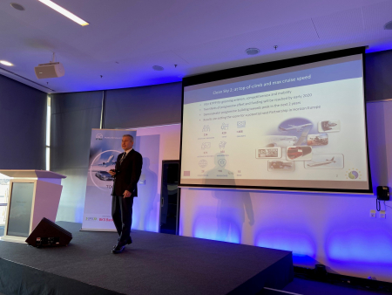

05 December 2019

Clean Sky participated in the AIRCONTACT’19 event organised by the Aerospace Cluster Styria (ACstyria), which took place in Graz (Austria) on 3-4 December 2019. This event brought together more than 100 Austrian and German aviation stakeholders to discuss evolutions in the aviation sector and the revolution in the supply chain.

Christos Vasilakos, Clean Sky Policy Officer, presented Clean Sky’s work in leading the way towards a low-carbon aviation system. He highlighted that the grand challenge facing the aviation sector is to reach climate neutrality by 2050 and explained how it can be achieved, with one integrated programme and approach for upstream research to large-scale demonstrators. To meet the ambitious vision for aviation, Dr. Vasilakos supported that an inclusive, ambitious and institutionalised European Partnership for Clean Aviation under Horizon Europe is the most effective and impactful means through which the aeronautics and air transport sectors can bring a decisive contribution towards a climate-neutral Europe. He also stressed the importance of the synergies that the potential Clean Aviation Partnership will create with other Partnerships and European, national and regional programmes, and the expected leverage effect and high impact.

Read more about the event [here](http://www.aircontact.at/ac/)